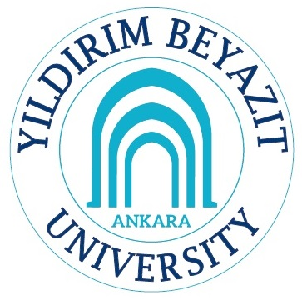

FACULTY OF ENGINEERING AND NATURAL SCIENCES
MECHANICAL ENGINEERING DEPARTMENT

POLAT KURT
135103111

May, 2016
ANKARA

