HARDNESS TEST
- OBJECT
The hardness test is a mechanical test for material properties which are used in engineering design, analysis of structures, and materials development. The principal purpose of the hardness test is to determine the suitability of a material for a given application, or the particular treatment to which the material has been subjected. The ease with which the hardness test can be made has made it the most common method of inspection for metals and alloys.

- INTRODUCTION
Hardness is defined as the resistance of a material to permanent deformation such as indentation, wear, abrassion, scratch. Principally, the importance of hardness testing has to do with the relationship between hardness and other properties of material. For example, both the hardness test and the tensile test measure the resistance of a metal to plastic flow, and results of these tests may closely parallel each other. The hardness test is preferred because it is simple, easy, and relatively nondestructive.

There are many hardness tests currently in use. The neccessity for all these different hardness tests is due to the need for categorizing the great range of hardness from soft rubber to hard ceramics.

- THEORY
Current practice divides hardness testing into two categories: macrohardness and microhardness. Macrohardness refers to testing with applied loads on the indenter of more than 1 kg and covers, for example, the testing of tools, dies, and sheet material in the heavier gages. In microhardness testing, applied loads are 1 kg and below, and material being tested is very thin (down to 0.0125 mm, or 0.0005 in.). Applications include extremely small parts, thin superficially hardened parts, plated surfaces, and individual constituents of materials.
- Macro Hardness Testers Loads > 1 kg
- Rockwell
- Brinell
- Vickers
- Micro Hardness Testers < 1 kg
- Knoop diamond
- Vickers diamond pyramid

  - Macro Hardness Test Methods
    - Rockwell Hardness Test
The Rockwell hardness test method consists of indenting the test material with a diamond cone or hardened steel ball indenter. The indenter is forced into the test material under a preliminary minor load $F_{0}$ (Fig. 1A) usually 10 kgf. When equilibrium has been reached, an indicating device, which follows the movements of the indenter and so responds to changes in depth of penetration of the indenter is set to a datum position. While the preliminary minor load is still applied an additional major load is applied with resulting increase in penetration (Fig. 1B). When equilibrium has again been reach, the additional major load is removed but the preliminary minor load is still maintained. Removal of the additional major load allows a partial recovery, so reducing the depth of penetration (Fig. 1C). The permanent increase in depth of penetration, resulting from the application and removal of the additional major load is used to calculate the Rockwell hardness number.
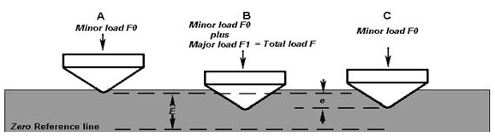
Figure 1. Rockwell Principle

There are several considerations for Rockwell hardness test
- Require clean and well positioned indenter and anvil
- The test sample should be clean, dry, smooth and oxide-free surface
- The surface should be flat and perpendicular to the indenter
- Low reading of hardness value might be expected in cylindrical surfaces
- Specimen thickness should be 10 times higher than the depth of the indenter
- The spacing between the indentations should be 3 to 5 times of the indentation diameter
- Loading speed should be standardized.
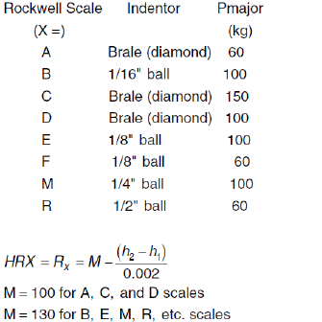
    - The Brinell Hardness Test
The Brinell hardness test method consists of indenting the test material with a 10 mm diameter hardened steel or carbide ball subjected to a load of 3000 kg. For softer materials the load can be reduced to 1500 kg or 500 kg to avoid excessive indentation. The full load is normally applied for 10 to 15 seconds in the case of iron and steel and for at least 30 seconds in the case of other metals. The diameter of the indentation left in the test material is measured with a low powered microscope. The Brinell harness number is calculated by dividing the load applied by the surface area of the indentation. When the indentor is retracted two diameters of the impression, d₁ and d₂ , are measured using a microscope with a calibrated graticule and then averaged as shown in Fig.2(b).
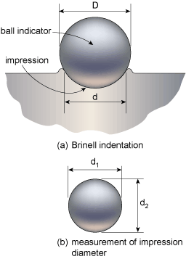

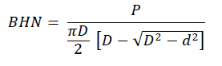
Where:
P is the test load [kg]
D is the diameter of the ball [mm]
d is the average impression diameter of indentation [mm]

Figure 2. Brinell Principle

The diameter of the impression is the average of two readings at right angles and the use of a Brinell hardness number table can simplify the determination of the Brinell hardness. A well structured Brinell hardness number reveals the test conditions, and looks like this, "75 HB 10/500/30" which means that a Brinell Hardness of 75 was obtained using a 10mm diameter hardened steel with a 500 kilogram load applied for a period of 30 seconds. On tests of extremely hard metals a tungsten carbide ball is substituted for the steel ball. Compared to the other hardness test methods, the Brinell ball makes the deepest and widest indentation, so the test averages the hardness over a wider amount of material, which will more accurately account for multiple grain structures and any irregularities in the uniformity of the material. This method is the best for achieving the bulk or macro-hardness of a material, particularly those materials with heterogeneous structures.

    - Vickers Hardness Test
The Vickers hardness test method consists of indenting the test material with a diamond indenter, in the form of a right pyramid with a square base and an angle of 136 degrees between opposite faces subjected to a load of 1 to 100 kgf. The full load is normally applied for 10 to 15 seconds. The two diagonals of the indentation left in the surface of the material after removal of the load are measured using a microscope and their average calculated. The area of the sloping surface of the indentation is calculated. The Vickers hardness is the quotient obtained by dividing the kgf load by the square mm area of indentation.
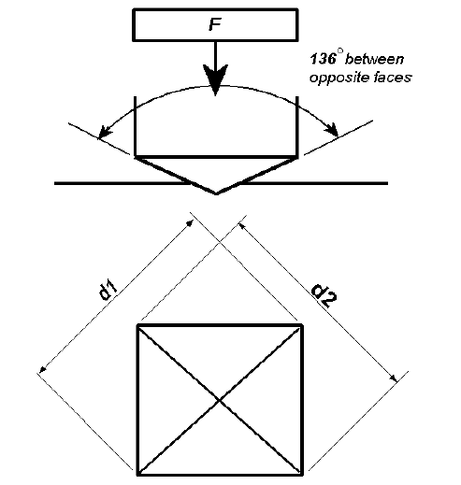
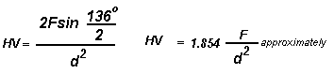

F= Load in kgf
d = Arithmetic mean of the two diagonals, d1 and d2 in mm
HV = Vickers hardness

Figure 3. Vickers Principle

When the mean diagonal of the indentation has been determined the Vickers hardness may be calculated from the formula, but is more convenient to use conversion tables. The Vickers hardness should be reported like 800 HV/10, which means a Vickers hardness of 800, was obtained using a 10 kgf force. Several different loading settings give practically identical hardness numbers on uniform material, which is much better than the arbitrary changing of scale with the other hardness testing methods. The advantages of the Vickers hardness test are that extremely accurate readings can be taken, and just one type of indenter is used for all types of metals and surface treatments. Although thoroughly adaptable and very precise for testing the softest and hardest of materials, under varying loads, the Vickers machine is a floor standing unit that is more expensive than the Brinell or Rockwell machines.

Hardness testing in estimating other material properties:

Hardness testing has always appeared attractive as a means of estimating other mechanical properties of metals. There is an empirical relation between those properties for most steels as follows:

UTS = 0.35*BHN (in kg/mm2)

This equation is used to predict tensile strength of steels by means of hardness measurement. A reasonable prediction of ultimate tensile strength may also be obtained using the relation:
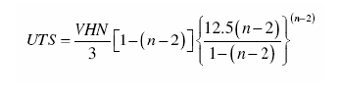
where VHN is the Vickers Hardness number and n is the Meyer’s index, a measure of the effect of the deformation on the hardness of the material.
The 0.2 percent offset yield strength can be determined with good precision from Vickers hardness number according to the relation: (Hint: For steels, the yield strength can generally be taken as 80% of the UTS as an approximation)

  - Micro Hardness Test Methods

The term microhardness test usually refers to static indentations made with loads not exceeding 1 kgf. The indenter is either the Vickers diamond pyramid or the Knoop elongated diamond pyramid. The procedure for testing is very similar to that of the standard Vickers hardness test, except that it is done on a microscopic scale with higher precision instruments. The surface being tested generally requires a metallographic finish; the smaller the load used, the higher the surface finish required.

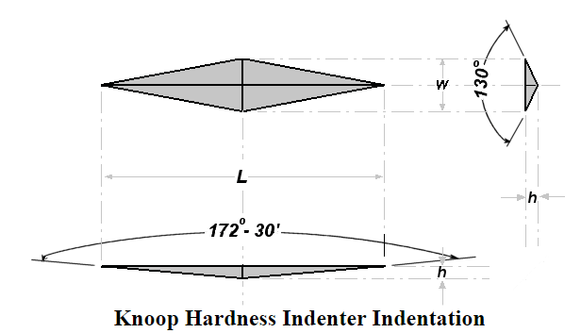

The Knoop hardness number KHN is the ratio of the load applied to the indenter, P (kgf) to the unrecovered projected area A (mm²).
KHN = F/A = P/CL²
Where:
F=applied load in kgf
A=the unrecovered projected area of the indentation in mm²
L=measured length of long diagonal of indentation in mm
C = 0.07028 = Constant of indenter relating projected area of the indentation to the square of the length of the long diagonal.
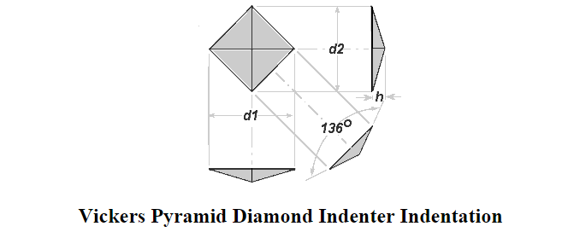
The Vickers Diamond Pyramid hardness number is the applied load (kgf) divided by the surface area of the indentation (mm²)
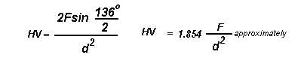
Where:
F= Load in kgf
d = Arithmetic mean of the two diagonals, d1 and d2 in mm
HV = Vickers hardness

Comparing the indentations made with Knoop and Vickers Diamond Pyramid indenters for a given load and test material:
- Vickers indenter penetrates about twice as deep as Knoop indenter
- Vickers indentation diagonal about 1/3 of the length of Knoop major diagonal
- Vickers test is less sensitive to surface conditions than Knoop test
- Vickers test is more sensitive to measurement errors than knoop test
- Vickers test best for small rounded areas
- Knoop test best for small elongated areas
- Knoop test good for very hard brittle materials and very thin sections
- EXPERIMENTS
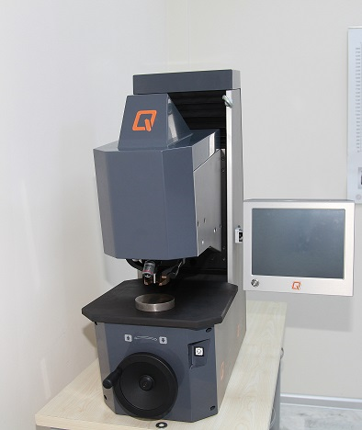
Selected samples will be selected to be tested by Brinell, Vickers and Rockwell hardness test, the results are given to students in the class lab by the Qness hardness test machine in Fig. 4. Different materials specimens will be tested in this laboratory experiment namely: aluminum alloy, carbon steel, brass, commercial pure copper, brass, and stainless steel etc.
Figure 4. Hardness test equipment

  - Results

Samples will be selected to be tested by Brinell, Vickers and Rockwell hardness test, the results are given to students in the class lab.
- For Brinell experiment, student has to calculate the BHN and depth of impression (h) through the following formulas for each material tested:
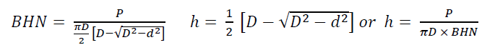
In the class, the values of P and d (d and d ) hane been given to students.
- For Vickers experiment, student has to calculate the VHN through the following formula for each material tested:
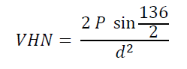
In the class, the values of P and d ($d_{1}$ and $d_{2}$ ) had been given to students.

- For Rockwell experiment, student has to calculate the depth ($h_{2}$-$h_{1}$) due to the major load through the following formulas for each used indenter:
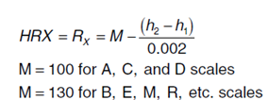

- Which factors effect the selecting of the appropirate hardness test?
- Discuss the advantages and disadvantages of the Brinell, Vickers and Rockwell Hardness Tests.
- Discuss the relationship between hardness and tensile properties.

- REPORT
In your laboratory reports must have the followings;
a) Cover
b) A short introduction
c) All the necessary calculations using measured data.
d) Discussion of your results and a conclusion.

References
ASM International, Hardness Testing, 2nd Edition, 06671G.
http://www.gordonengland.co.uk/
Metals Handbook, 9th ed., Mechanical Testing, Vol. 8, 1990.
N. Dowling, Mechanical Behavior of Materials, Prentice Hall, 1993.

