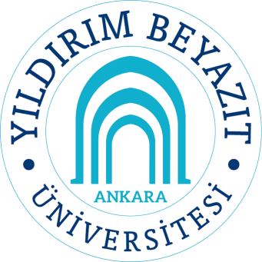 | Course name: MATH 501 – Algebra I |  |  |  |  | Department: Mathematics |  |  |  |  | Semester
 |  |  |  |  |  |  |  |  |  |  | 1
 | Methods of Education |  |  |  |  |  |  |  |  |  | Credit (ECTS)
 | Lecture | Recitation/  (Etud) | Lab | Project/Field Study |  |  | Homework | Other |  | Total | 8
 | 100 | 20 | 0 | 50 |  |  | 50 | 20 |  | 240 | 8
Language | English
Compulsory/Elective | Elective
Prerequisites | None
Course Contents
  Week | Subjects
  1 | - Groups, subgroups, cyclic groups,  - Finite groups, permutations
  2 | - Alternating groups, quotient groups
  3 | - Isomorphism theorems  - Direct products of groups
  4 | - Free abelian groups, free groups  - Finitely generated abelian groups
  5 | - Group actions on sets  - Series of groups  - Sylow theorems
  6 | - Rings, ring homomorphisms, ideals
  7 | - Prime and maxiamal ideals
  8 | - Quotient rings  - Gröbner bases for ideals
  9 | - Factorization in commutative rings
  10 | - Euclidean domains
  11 | - Principal ideal domains
  12 | - Unique factorization domains
  13 | - Polynomial rings
  14 | - Factorization in polynomial rings  - Power series
Course Objectives | The purpose of this course is  - to have students understand basic properites of groups and rings.
Learning Outcomes and  Competences | At the and of this course students will  - be able to understand structure of groups and use them whenever necessary,  - be able to understand structure of rings and use them whenever necessary.
Textbook and /or References | - Algebra, Larry C. Grove.  - A First Course in Abstract Algebra, J. B. Fraleigh, Seventh Edition.  - Algebra, Thomas W. Hungerford.
Assessment Criteria |  |  |  |  | If any, mark as (X) |  |  |  | Percentage (%)
Assessment Criteria | Midterm Exams |  |  |  | X |  |  |  | 40
Assessment Criteria | Quizzes
Assessment Criteria | Homework |  |  |  | X |  |  |  | 10
Assessment Criteria | Projects
Assessment Criteria | Term Paper
Assessment Criteria | Laboratory work
Assessment Criteria | Other
Assessment Criteria | Final Exam |  |  |  | X |  |  |  | 50
Instructors

