You can join the TED Translators Community and become a subtitle translator for TED videos. It’s very simple to do. All you need to do is create a TED account, go to the TED homepage and click on ‘Translate’ under the ‘Join’ section.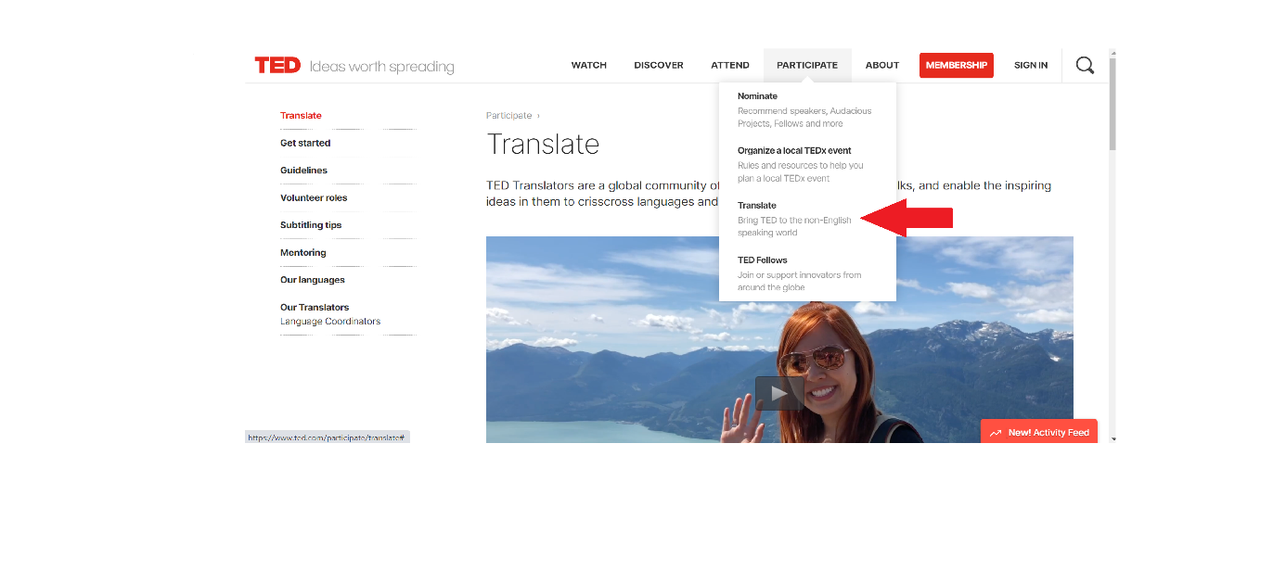
TED will then send you an email within 1 to 5 days to let you know whether you have been accepted or not. They will then ask you to watch a few videos and pass a short test. If you pass this test, you will be appointed as a translator. You will then be asked to log in to a site called ‘Captionhub’ using your TED account. You can view TED’s videos in the Projects section (Figure 1.1). You can translate any video you wish. Various parameters are available. For example, you can choose the language of the video and the duration of the videos.
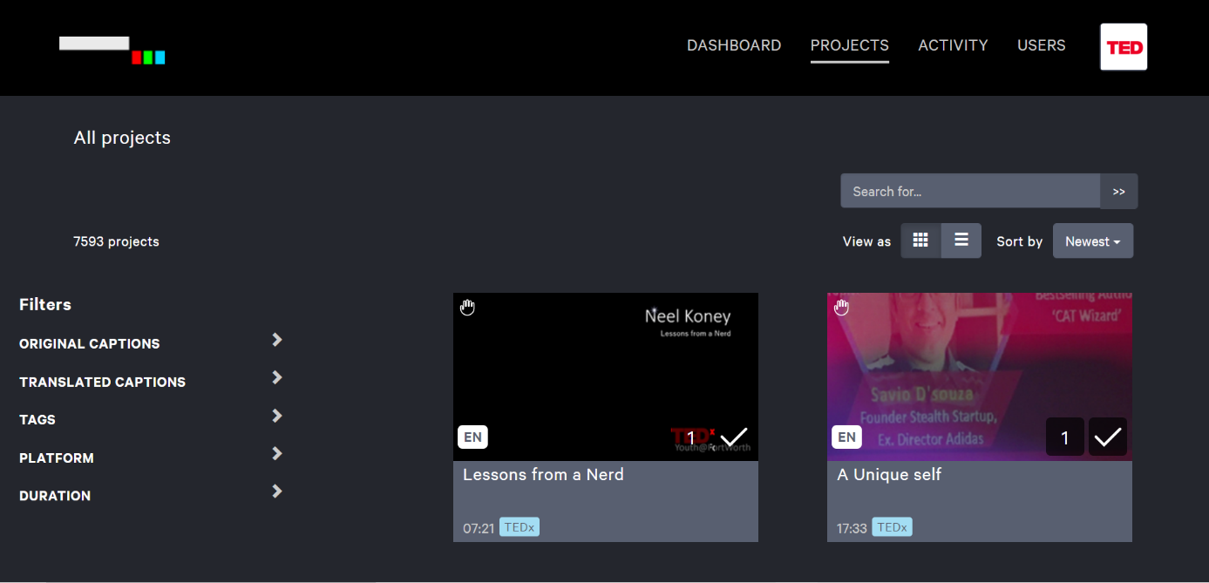
Şekil 1.1

There is also a performance dashboard. Here you can see how many projects you have taken on each month 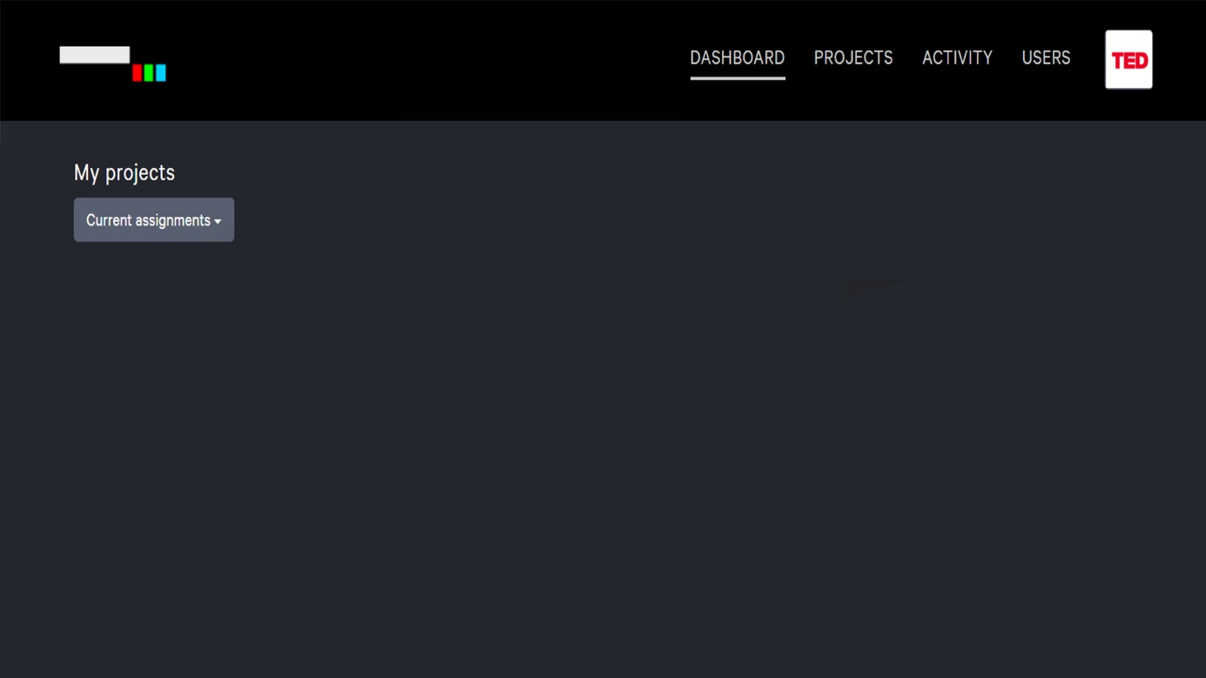
In addition, you can see what you’ve been doing in the ‘Activity’ section. The ‘Users’ button is also used to view users. In particular, you can search here for a user who can review your translations. The interface is laid out in a very straightforward manner.
The TED system works as follows: a translator takes on a project; once the project has been translated, it is reviewed by a ‘reviewer’, and the project is then ready for publication. However, the important point is that one day you too could become a ‘reviewer’. To do so, you must have at least 10 projects already published. As long as you are translating, you remain solely a linguist and translator.
You can volunteer as a TED translator and play a key role in keeping the flow of information going.

