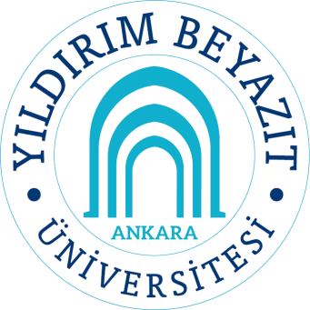 | Course name: MATH 536 Graph Theory |  |  |  |  |  | Department: Mathematics |  |  |  |  | Semester
 |  |  |  |  |  |  |  |  |  |  |  | 2
 | Methods of Education |  |  |  |  |  |  |  |  |  |  | Credit (ECTS)
 | Lecture | Recitation/  (Etud) | Lab | Project/Field Study |  | Homework |  |  | Other | Total |  | 8
 | 42 | 0 | 0 | 90 |  | 60 |  |  | 48 | 240 |  | 8
Language | English
Compulsory/Elective | Departmental Elective
Prerequisites | None
Course Description | Types of graphs, directed graphs, matchings, connectivity, planar graphs, coloring of graphs, Ramsey theory.
Course Contents
  Weeks | Subjects
  1 | Graphs as models, paths, cycles, degree
  2 | Directed graphs
  3 | Trees, bipartite graphs
  4 | Matchings, Hall’s Theorem
  5 | Independent sets, dominating sets
  6 | Factors
  7 | Connectivity
  8 | Planar graphs
  9 | Review, Midterm Exam
  10 | Vertex coloring
  11 | Chromatic number, Brook’s Theorem
  12 | Chordal graphs
  13 | Ramsey Theory
  14 | Ramsey numbers
Course Objectives | The purpose of this course is to provide basic concepts in graph theory, introduce main definitions and theorems related to graphs.
Learning Outcomes and  Competences | By a successful completion of this course, students should be able to:  - Model a problem in terms of graphs,  - Apply basic theorems in graph theory,  - Make use of graphs to solve some optimization problems.
Textbook and /or References | References:  - Douglas B. West, Introduction to Graph Theory, 2nd edition, Pearson, 2002.  - Reinhard Diestel, Graph Theory, Electronic edition, Springer, 2000.
Assessment Methods and Criteria | In-Term Studies |  |  |  |  |  |  | Quantity |  |  | Percentage%
Assessment Methods and Criteria | Mid-terms |  |  |  |  |  |  | 1 |  |  | 25
Assessment Methods and Criteria | Quizes |  |  |  |  |  |  | 0 |  |  | 0
Assessment Methods and Criteria | Assignments |  |  |  |  |  |  | 3 |  |  | 25
Assessment Methods and Criteria | Attendance |  |  |  |  |  |  | 0 |  |  | 0
Assessment Methods and Criteria | Practice |  |  |  |  |  |  | 0 |  |  | 0
Assessment Methods and Criteria | Project |  |  |  |  |  |  | 1 |  |  | 20
Assessment Methods and Criteria | Final Examination |  |  |  |  |  |  | 1 |  |  | 30
Assessment Methods and Criteria | Total |  |  |  |  |  |  | 6 |  |  | 100
ECTS Allocated Based on  Student Workload | Activities |  |  |  | Quantity |  |  | Duration |  |  | Total Work Load
ECTS Allocated Based on  Student Workload | Course Duration |  |  |  | 14 |  |  | 3 |  |  | 42
ECTS Allocated Based on  Student Workload | Hours for off-the-c.r.study |  |  |  | 14 |  |  | 5 |  |  | 70
ECTS Allocated Based on  Student Workload | Assignments |  |  |  | 3 |  |  | 20 |  |  | 60
ECTS Allocated Based on  Student Workload | Mid-terms |  |  |  | 1 |  |  | 20 |  |  | 20
ECTS Allocated Based on  Student Workload | Project |  |  |  | 1 |  |  | 20 |  |  | 20
ECTS Allocated Based on  Student Workload | Final Examination |  |  |  | 1 |  |  | 28 |  |  | 28
ECTS Allocated Based on  Student Workload | Total |  |  |  | 34 |  |  | 96 |  |  | 240
Instructors

